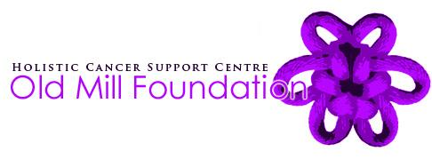

How to Leave a Gift in your Will
Legacies can be left to the Old Mill Foundation in a number of ways – it isn’t complicated and needn’t be expensive. Most commonly, people choose to make a gift of:
- a single lump sum (a pecuniary legacy)
- a percentage of the residue of an estate once it is settled (a residuary legacy)
We advise you to visit a solicitor to seek advice about how to make a Will. Solicitors will charge a fee, but you will receive sound professional advice and can be sure that your wishes are accurately reflected. The general clause wordings below can be used when in discussion with your solicitor.

Pecuniary bequest - to leave a single lump sum to the Old Mill Foundation:
- I give free of tax to the Old Mill Foundation, Meyricks Mill, Hendy Rd, Penclawdd, Swansea, SA4 3XE Registered Charity Number 1125120, the sum of £ …… [words and figures] to be used for its general charitable purposes, and I declare that the receipt of their Chief Executive or other proper officer shall be a full and sufficient discharge.

Residuary bequest - to leave all or a % of the residue of your estate to the Old Mill Foundation:

I give all (or a …...% share of) the residue of my estate to the Old Mill Foundation, Meyricks Mill, Hendy Rd, Penclawdd, Swansea, SA4 3XE Registered Charity Number 1125120, to be used for its general charitable purposes and I declare that the receipt of their Chief Executive or other proper officer shall be a full and sufficient discharge.

If you have already made a Will

You can make simple amends to an existing Will in the form of a codicil. This is a supplement to your Will enabling you to include new instructions and delete old ones without having to go through the task of rewriting the whole Will.

Your Will and any codicils to it are legal documents. Alterations, if not made according to strict regulations and the law, may be invalid or open to challenge. It is very important you seek legal advice before making any changes to your Will.

Inheritance Tax
All charitable legacies are free from inheritance tax. Furthermore, if your estate is worth more than £350,000 (or £650,000 for a couple) you can limit the amount of inheritance tax you pay by leaving a gift to charity.
Let us Know
How much contact you have with the Old Mill Foundation is entirely your choice. We can only honour your wishes if we know about them. The Old Mill Foundation feels a great debt of gratitude to donors that remember us in this way. If you wish to remain anonymous or if you want to know more about an aspect of our work please let us know.

